Database Design Document
Evan Dauenbaugh, Grant Meidinger, Navy Oss
CSCI 455: Database Management

Table of Contents
1. Introduction 1
1.1 Summary of Previous Documents 1
1.2 Design Objectives 1
1.3 Definitions of Terms Used 2
2. Subsystem and Application Overview 2
2.1 Application Descriptions 3
2.2 User Interface Prototypes 3
2.2.1 Login Interface 3
2.2.2 New Patient Registration 4
2.2.3 Patient Interface 4
2.2.4 Doctor Interface 5
2.2.5 Nurse Interface 5
2.2.6 Admin Interface 6
3. Database Design Considerations 7
3.1 Entity Mapping 7
3.2 Schema Normalization 8
3.3 Relational Schema Diagram 9
3.4 Data Backup and Recovery 10
3.5 Order Log 11
4. SQL Statement Examples 11
4.1 Register New Patient 11
4.2 Access and Update Patient Records 12
4.3 Create Medical Record (Doctor) 12
4.4 Upload and View Patient Documents 13
4.5 Schedule and Manage Appointments 13
4.6 Manage User Roles (Admin) 14
4.7 Audit Logging 14
4.8 Update Personal Information (Patient) 15
5. Data Access Requirements 15
5.1 Database Administrator 15
5.2 Doctor 15
5.3 Nurse 16
5.4 Patients 16
6. Appendix 16
6.1 Relational Schema Diagram 16
6.2 Entity Relationship Diagram 17

1. Introduction

1.1 Summary of Previous Documents
The previous deliverable focused on defining the requirements for the EMR System. This included identifying the project objectives, scope, functional and non-functional requirements, hardware and software requirements, GUI requirements, use cases, entity relationships, and compliance requirements.
The system was designed to be used by patients, doctors, nurses, and administrators through a secure platform. Key functions defined in the previous document included patient registration, secure login with optional MFA, appointment scheduling, medical record access control and management, secure document uploads, and logging.
Additionally, an Entity Relationship Diagram (ERD) and use case scenarios were developed to show how different users interact with the system. The topics covered in the previous deliverable serve as the foundation for the database and system design presented in this deliverable.

1.2 Design Objectives
The goal of this system design is to create a secure, scalable, and efficient database for electronic medical records.
Key design objectives include:
- Secure storage and transmission of sensitive patient data.
- Role-based access control for patients, doctors, nurses, and administrators.
- A normalized database design to reduce redundancy.
- Supporting multi-user access and stability.
- Maintain audit logs to track user's actions.

1.3 Definitions of Terms Used
- EMR (Electronic Medical Record): A digital record of a patient's medical history such as diagnoses, treatments, and test results.
- Database Management System: Software used to store, manage, and retrieve data from a database.
- ERD (Entity Relationship Diagram): A diagram showing entities in a system and how they relate to each other.
- Entity: A concrete or abstract concept such as a person, place, or thing, or events represented by a table in the database.
- Relational Schema: A representation of database tables with attributes and relationships.
- Table: A collection of related data organized into rows and columns.
- Attribute: A specific piece of data stored in a table.
- Primary Key: An attribute or set of attributes that uniquely identify each row.
- Foreign Key: An attribute in one table that references the primary key of another table, used to establish relations between tables.
- Normalization: The process of organizing a database to reduce redundancy and improve data integrity.
- Role Based Access Control: A security method that restricts access to resources based on a user's role.
- Audit Log: A record of system actions performed by users.
- HIPAA: Regulation that ensures protection and privacy of patient health information.
- Use Case: Diagram defining interactions between a user role and the database system.
- Electronic Medical Record Keeping System (EMRKS): Centralized platform for storing and retrieving medical data.

2. Subsystem and Application Overview
The EMR System is designed as a multiuser platform that will enable patients, healthcare providers, and admins to securely access and manage medical information. The system is accessible through a web-based interface and supports real time data access, concurrent usage, and role-based permissions.
The EMRS has multiple subsystems that will handle patient data managment, appointments, records access, and admin operations. Each system is specific to the different user roles.

2.1 Application Descriptions
The patient portal application is a web-based interface that allows patients to register, log in, and manage their information. Patients can view and schedule appointments and see their records. They are also able to upload and download documents into their records.
The clinic access system is used by healthcare providers to access and manage patient records. Doctors have full access to medical records, and can create, update, and review the documents, prescriptions, and lab results. Nurses have access to essential patient information like vitals, notes, and basic medical history with limited editing permissions. The system allows for concurrent access.
The administrative management system is responsible for patient records, managing roles/permissions, and system operations. Administrators are able to create new patient profiles, manage permissions, and generate reports related to the systems' usage. The system also includes audit features to track access and any modifications made.
The appointment and scheduling system enables both patients and staff to schedule, reschedule, and cancel appointments. It provides real-time availability and ensures that the information is consistent across users.

2.2 User Interface Prototypes
To illustrate the design of the EMR System, some interface prototypes have been made. They represent the intended functionality and layout of the system but are not the final design and will be different in the final system. Their purpose is to demonstrate what the interface may look like for each role

2.2.1 Login Interface
The login interface is the entry point for all users. Users will enter their credentials to gain access to the system. It is designed to detect user roles and give them the correct interface. It will also provide error messages for incorrect login attempts.
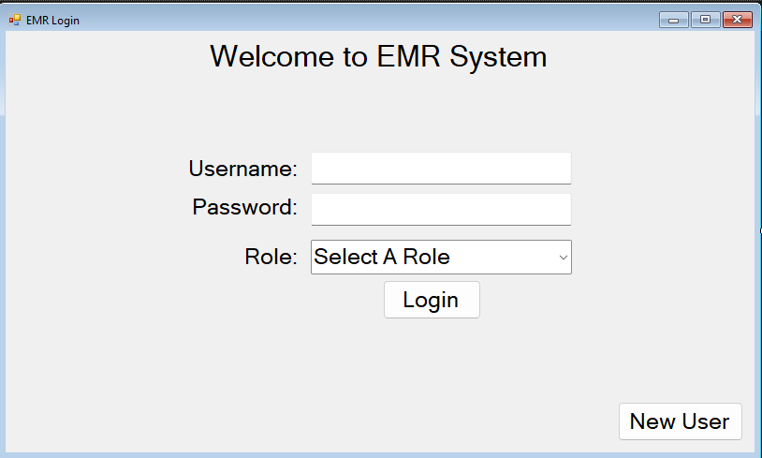

2.2.2 New Patient Registration
The new patient registration interface allows for patients to create a new account for the system. The user needs to enter some personal information for the account to be created. The system will validate that the fields are valid before making the account. Once completed a new account will be made and the user can log in using the login interface.
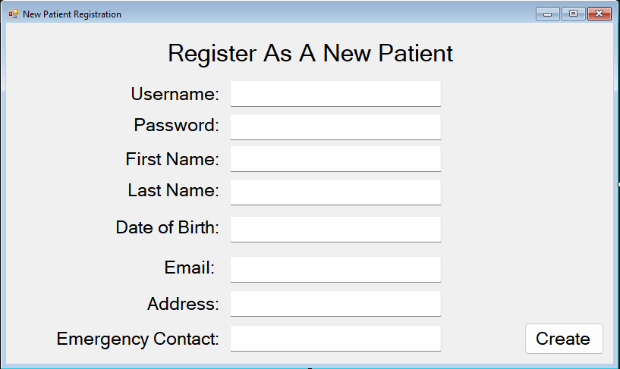

2.2.3 Patient Interface
The patient interface provides a dashboard where patients can access and manage their health information. They can view both their personal and medical information. They can also access any of their medical documents, as well as download them, or upload new files. They can also schedule appointments as well as view upcoming and previous visits.
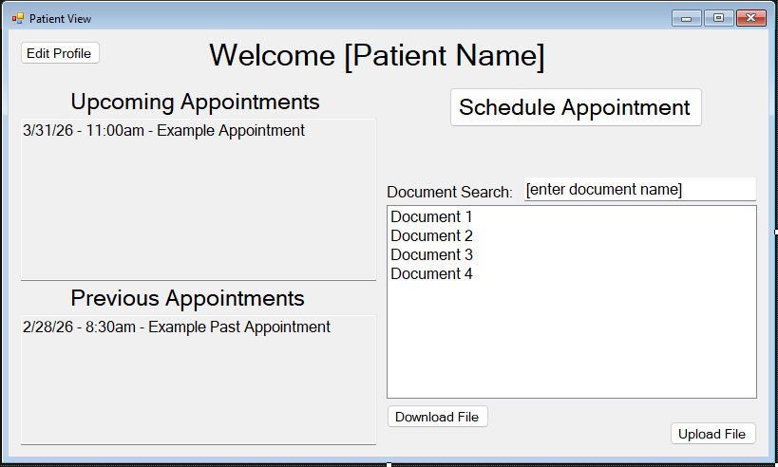

2.2.4 Doctor Interface
The doctor interface gives doctors access to patient records and other information needed for making medical decisions. Doctors can view complete medical histories and add or edit documents in them. It supports real time updates as well as concurrent access so multiple users can access at once as well as ensure that data is up to date.
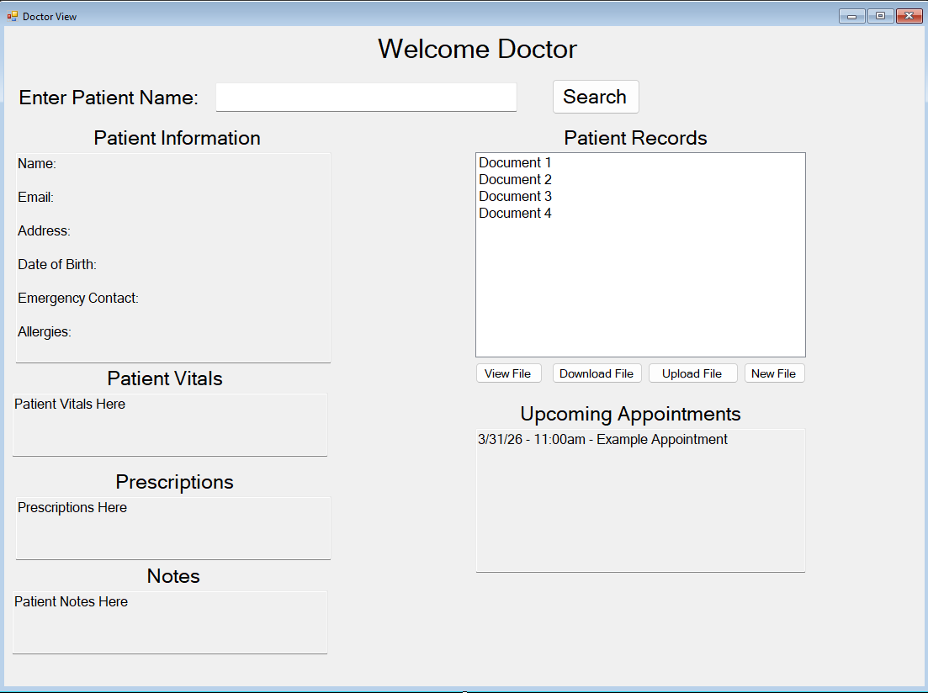

2.2.5 Nurse Interface
The nurse interface provides access to essential patient information while also having less permission than doctos. Nurses can view patient info, vital signs, and basic history. They can update the patient's vitals and notes if needed. The interface also allows access to a patient’s upcoming appointments. It is designed to have easy access to required information while also restricting permissions.
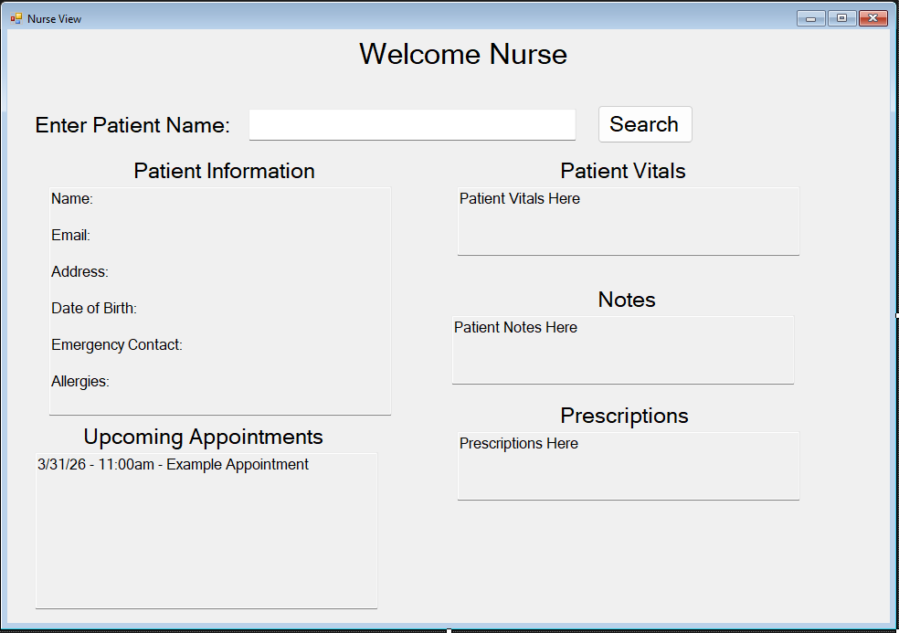

2.2.6 Admin Interface
The admin interface provides system wide management capabilities and oversight of system operations. Admins are responsible for managing user roles and permissions. The interface allows them to view user information, roles, and any records attached to the user's account. The system will log what is accessed and if any changes are made.
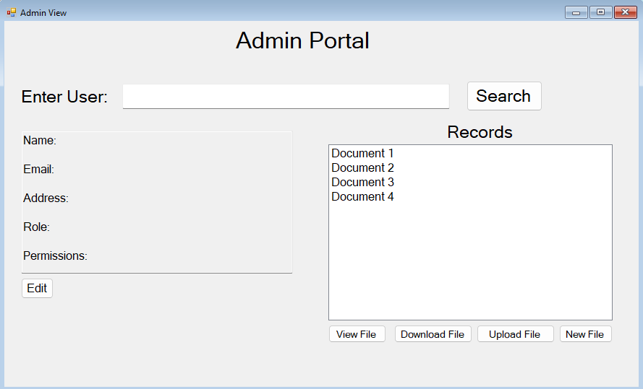

3. Database Design Considerations
When designing the Electronic Medical Record Keeping System (EMRKS) database, security, scalability, and data integrity will be prioritized. Due to the sensitive nature of healthcare data, the system must ensure strict access control, accurate record keeping, and compliance with regulations such as HIPAA. Additionally, the database is designed to support multiple user access and future system expansion. By focusing on these characteristics, the final implementation will provide a secure and efficient flatform for managing patient records while remaining adaptable to the needs of healthcare providers.

3.1 Entity Mapping
To implement the entities outlines in the conceptual design and ERD, several adjustments were required to ensure compatibility with MySQL and relational database standards. Each entity in the ERD is mapped to a corresponding table, and all attributes are represented as columns within those tables.

Core entities such as Patient, User, Medical_Record, Appointment, Document, and Audit_Log are each implemented as individual tables. Primary keys are assigned to uniquely identify each record, while foreign keys are used to establish relationships between entities. For example, patient records are linked to users (doctors or nurses) through foreign keys, and appointments are associated with both patients and healthcare providers.

This mapping ensures that all system functionalities, including patient registration, record management, appointment scheduling, and audit tracking, are supported directly within the database structure.

3.2 Schema Normalization
Another important design consideration is ensuring that all relations in the schema adhere to normalization standards. The EMRKS database is normalized to third normal form to eliminate redundancy and maintain data consistency.

First normalization form was enforced by ensuring that all attributes contain atomic values and that no repeating groups or multi-valued attributes exist. For example, patient contact information is stored as individual fields rather than grouped values.

Second normal form was achieved by ensuring that all non-key attributes are fully dependent on the primary key. This eliminated partial dependencies in tables involving composite keys.

Third normal form was applied by removing transitive dependencies. For instance, provider information is stored in the User table rather than being duplicated within patient or appointment records. In cases where multi-valued relationships were necessary, such as potential future support for multiple providers per appointment, additional junction tables and be introduced to maintain the normalization.
Figure 3.2.1 - Normalization of Patient and Medical Record Entities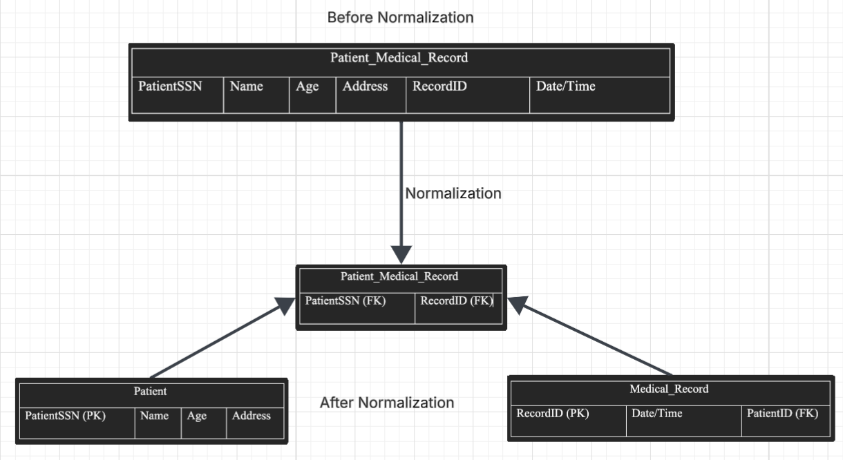
Fig. 3.2.1

Figure 3.2.2 - Normalization of Appointment and User Relationships
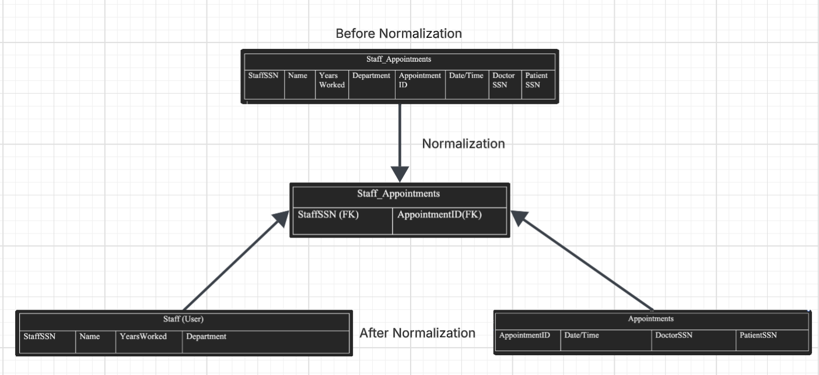Fig. 3.2.2

3.3 Relational Schema Diagram
The relational schema diagram represents the same information as the ERD but in a more implementation-focused format. It emphasized the relationships between tables through primary key and foreign key constraints.

In the EMRKS schema, the Patient entity serves as the central component, with related entities such as Medical_Record, Appointment, Document, and Audit_Log connected through foreign key relationships. The User entity is also central was it defines system roles (patient, nurse, doctor, administrator) and controls access to data.

This diagram provides a clearer understanding of how the database will function in practice, particularly in enforcing referential integrity and supporting role-based access control.
Figure 3.3.1 - Relational Schema Diagram of the EMRKS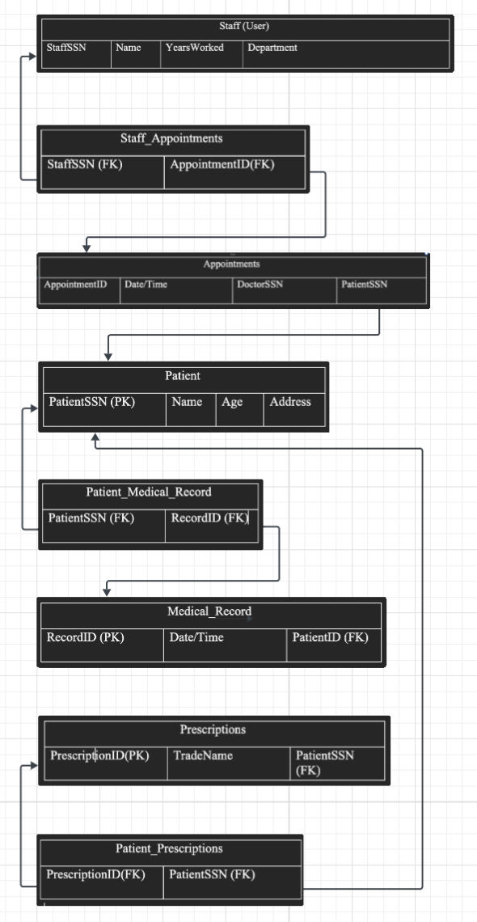
Fig. 3.3.1

3.4 Data Backup and Recovery
To protect sensitive patient data from loss due to system failures, hardware issues, or security incidents, a comprehensive backup and recovery strategy is implemented. A backup database will be maintained separately from the primary system, ensuring that data can be restored if necessary.

The backup system will store a complete copy of the EMRKS database and will be updated on a regular basis. While the exact interval may vary depending on system usage, daily backups are recommended due to the critical nature of healthcare data.

In addition to full backups, incremental backups may be used to capture changes between backup intervals. All backup data will be encrypted both in transit and at rest to comply with security requirements. In the event of data loss, the system can be retored using the most recent backup, minimizing downtime and preserving data integrity.

3.5 Order Log
For auditing and compliance purposes, the EMRKS will maintain a log of all critical system actions, referred to as the Audit Log. This log functions similarly to an order log in other systems but is adapted to track access and modifications to patient data.

The audit log records actions such as viewing, creating, updating, deleting, and downloading patient records. Each log entry includes the user identifier, role, action type, and timestamp. This ensures full traceability of all interactions with sensitive data.

The audit log will be stored in a separate table within the database and will be accessible only to authorized administrative users. To preserve data integrity, log entries will be read-only and cannot be modified once created. This logging mechanism supports compliance with HIPAA requirements, enhances system security, and provides a reliable method for monitoring user activity and investigating potential issues.

4. SQL Statement Examples
The following sections will contain some pseudocode representing possible queries and data definition statements used to retrieve and update information in the EMR System. The statements are some common operations performed by patients, doctors, nurses, and admins in the system’s interfaces. This is not a full list but rather one focusing on the key scenarios.

4.1 Register New Patient
// Adding new patient into the patient table
INSERT NEW ROW INTO PATIENT TABLE
WITH VALUES (firstName, lastName, dob, email, address, emergencyContact) =
(“John”, “Doe”, “2004-01-01", “email@email”, “1234 Street Road”, “Contact Info”);

// Creating login credentials for the patient
INSERT NEW ROW INTO USER_ACCOUNT TABLE
WITH VALUES (userID, username, password, role) =
(p.id, “username”, “password”, “PATIENT’);

4.2 Access and Update Patient Records
// Doctor or nurse retrieves patient records
SHOW ATTRIBUTES (patientID, medicalHistory, allergies, medications)
FROM PATIENT_RECORDS
WHERE (patientID = p.id);

// Updating patient record
ALTER ROW IN PATIENT_RECORDS TABLE
WHERE (recordID = r.id)
CHANGE VALUE (notes) TO (“Updated Notes”);

// Logging new update action
INSERT NEW ROW INTO AUDIT_LOG TABLE
WITH VALUES (userID, actionType, timestamp) =
(u.id, “Update Record”, currentTime);

4.3 Create Medical Record (Doctor)
// Doctor creates new medical record for a patient
INSERT NEW ROW INTO PATIENT_RECORDS TABLE
WITH VALUES (patientID, doctorID, diagnosis, treatment, notes, createdDate) =
(p.id, d.id, “Diagnosis”, “Treatment Plan”, “Notes”, currentDate);

4.4 Upload and View Patient Documents
// Patient uploads a document
INSERT NEW ROW INTO DOCUMENTS TABLE
WITH VALUES (patientID, fileName, fileType, uploadDate) =
(p.id, “lab_results.pdf”, “PDF”, currentDate);

// Retrieve patient documents
SHOW ATTRIBUTES (fileName, fileType, uploadDate)
FROM DOCUMENTS
WHERE (patientID = p.id);

4.5 Schedule and Manage Appointments
// Scheduling a new appointment
INSERT NEW ROW INTO APPOINTMENTS TABLE
WITH VALUES (patientID, doctorID, date, time, appointmentType, status) =
(p.id, d.id, “2026-04-01", “10:00”, “Checkup”, “Scheduled”);

// Viewing appointments
SHOW ATTRIBUTES (date, time, appointmentType, status)
FROM APPOINTMENTS
WHERE (patientID = p.id);

// Updating appointment (reschedule)
ALTER ROW IN APPOINTMENTS TABLE
WHERE (appointmentID = a.id)
CHANGE VALUE (date) TO (“2026-04-02")
CHANGE VALUE (time) TO (“10:30”);

// Cancel appointment
ALTER ROW IN APPOINTMENTS TABLE
WHERE (appointmentID = a.id)
CHANGE VALUE (status) TO (“Cancelled”);

4.6 Manage User Roles (Admin)
// Admin creates new staff account
INSERT NEW ROW INTO USER_ACCOUNT TABLE
WITH VALUES (username, password, role) =
(“doctor1”, “password”, “DOCTOR”);

// Update user role
ALTER ROW IN USER_ACCOUNT TABLE
WHERE (userID = u.id)
CHANGE VALUE (role) TO (“ADMIN”);

4.7 Audit Logging
// Log user access to patient record
INSERT NEW ROW INTO AUDIT_LOG TABLE
WITH VALUES (userID, patientID, actionType, timestamp) =
(u.id, p.id, “VIEW_RECORD”, currentTime);

// Retrieve audit logs
SHOW ATTRIBUTES (userID, actionType, timestamp)
FROM AUDIT_LOG
WHERE (patientID = p.id);

4.8 Update Personal Information (Patient)
// Patient updates their profile information
ALTER ROW IN PATIENT TABLE
WHERE (patientID = p.id)
CHANGE VALUE (address) TO (“New Address”)
CHANGE VALUE (email) TO (newemail@email);

5. Data Access Requirements
The EMRKS system enforces role-based access control to ensure that’s users can only access the authorized data for their role. Access permissions are defined for Database Administrators, Doctors, Nurses, and Patients to maintain data security, integrity, and compliance with regulation requirements. All user actions are logged for auditing purposes.

5.1 Database Administrator
The Database Administrator has full access to the system and is responsible for managing the databases, ensuring security, and maintaining system performance.
The Database Administrator can:
- View, create, update, and delete all records in the database.
- Manage database structure, including tables, relationships, and constraints.
- Create and manage user accounts, roles, and permissions.
- Monitor system performance and optimize queries.
- Perform data backups.
- Access and review logs and system activity.

5.2 Doctor
Doctors have the highest level of access among clinical staff and are responsible for diagnosing and treating patients. System and document access aligns for full medical record interactions. Doctors cannot modify system level settings or the database structure.
Doctors can:
- View complete patient records, such as medical history, lab results, and prescriptions.
- Create and update medical records, including diagnoses, treatment plans, and clinical notes.
- Prescribe medications and update prescription records.
- View and manage patient appointments
- Generate and export patient records.

5.3 Nurse
Nurses have limited access when compared to doctors. Nurses cannot create diagnoses or prescribe medications. Their access is limited for role separation and data integrity.
Nurses can:
- View patient records assigned to them.
- Update basic patient information such as vitals, notes, allergies, and contact information.
- View and manage appointments
- Access uploaded patient documents.

5.4 Patients
Patients have restricted access to ensure they can only view and manage their own information.
Patients can:
- View and update their personal profile information.
- View their medical records such as appointments, prescriptions, and lab results.
- Upload, view, and download their own documents.
- View, schedule, reschedule, or cancel appointments.
- Export their medical data when permitted.

6. Appendix
6.1 Relational Schema Diagram

Figure 6.1.1 - Enlarged Relational Schema Diagram for EMRKS

6.2 Entity Relationship Diagram
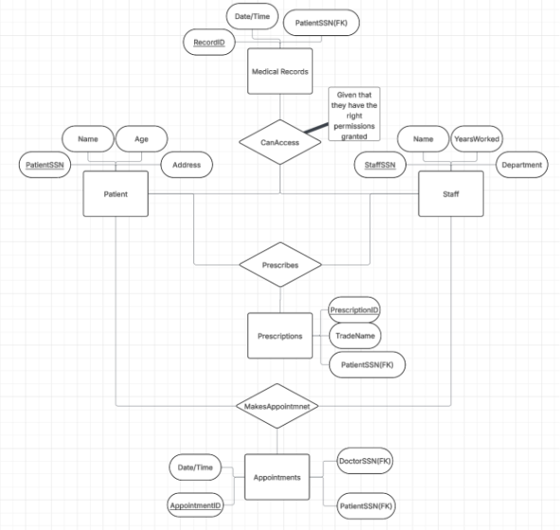
Figure 6.2.1 - Entity Relationship Diagram for Electronic Medical Record System

